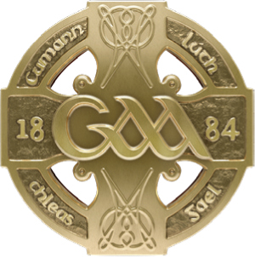
GAA GAA
Páirc an Chrócaigh Croke Park
Baile Átha Cliath 3 Dublin 3
Guthán +353 1 8658600 Telephone +353 1 8658600
Faics +353 1 8366420 Fax +353 1 8366420
www.gaa.ie www.gaa.ie

24ú Márta 2021

Do: Gach Rúnaí Chontae
Gach Runaí Chlub

Covid Update

A chara,

We are writing to provide you with a brief update on the position with regard to Covid-19 and to thank you for your ongoing patience in relation to the continued enforced delay in the resumption of G.A.A. activities.

2021 has already felt like a long year without any on field activity to sustain us. However, the reality of the pandemic and the continuing spread of the virus means we are likely to have to persevere for a little longer before anything like our normal level of activity can resume.

Clubs in the 26 Counties/National Fixtures Programme
In terms of the immediate future, it is expected that the Government in the South will publish any proposed changes to the current restrictions by the end of next week and we will communicate again with our Clubs and County’s at that point in terms of the implications for GAA activity.

In the interim, we would again reiterate that the GAA have not decided on what competitions may or may not be facilitated in any revised national fixture programme for 2021. As we have stated previously, such decisions will be a factor of how much time is ultimately available to us, both for an inter county season and for the broader participation levels that will be necessary for a meaningful club season at both adult and underage levels.

Clubs in the 6 Counties
The recent proposed changes to regulations North of the border have significant implications for Clubs in the 6 Counties.

A review by the NI Executive will be held on the week of April 5th and presuming restrictions are then eased as proposed, the following activities will be allowed from April 12th onwards for Clubs only in the 6 Counties:

- Training at adult and underage levels in groups of up to 15 people only, including coaches (full contact) is permitted.
- Use of dressing rooms or other indoor facilities is not permitted for the moment (exception: essential toilet facilities).
- Clubs should refer to and abide by the Gaelic Games Return to Play Document – an updated version will be circulated to all Clubs ahead of April 12th.
- Cover under both the Injury Benefit Fund and Liability insurance policy is conditional on clubs being in compliance with return to play guidelines and requirements.
- Particular care is advised in planning for travel to and from training – i.e. only persons from your own bubble should travel in the same vehicle.
- Games are not permitted until further notice.
- Use of other indoor facilities – such as bars, kitchens or meeting rooms – is not permitted under the current regulations.
- Outdoor Handball facilities may be used for Handball training
- Astro Turf facilities may be used by non-GAA bodies, presuming health guidelines are followed in relation to maximum numbers of 15.
- Walking tracks on GAA property may continue to be used.
- Other outdoor events, such as drive in bingo or fundraisers organized by our clubs and which involve people gathering in groups of more than 10 people are not permitted.

The above provisions relate to Club activity only. Collective Inter County training sessions are not permitted for any age group in either jurisdiction and breaches of this can and will be dealt with under Rule 7.2 (e).

2020 Injury Fund Extension to 31 May 2021
Given that no activity has been possible for January to March 2021 a further two-month extension of Injury Fund cover has been ratified by Coiste Bainistíochta. This will now take the 2020 cover term up until 31 May 2021.
This means that the GAA Injury Benefit Fund cover remains in place based on existing 2020 team registrations. Units do not need to register or pay for their 2021 teams until re-invited to do so. Details with regards to registering and payment for the 2021 GAA Injury Benefit Fund will issue once we have more clarity from Government as to what the coming months may look like.
It is a condition of the extended 2020 Injury Fund cover to 31 May 2021 that in advance of any permitted return to train or play in either April or May, “All players will still be required to be individually registered for the 2021 season on the new “Foireann” membership system.” 2020 player registrations will “NOT” carry over into 2021 and cover will be declined if a player is not fully registered for the 2021 season in advance of any return to train or play in 2021.

Pause on “Loss of Wages cover” from 1 January 2021
Following discussion at a meeting of Central Council on Saturday 20th March last, it was agreed to review the following two options as alternatives to the current pause that has been applied to the loss of wages cover that forms part of the wider Player Injury Benefit Fund.
- Offer all our playing members who may feel that loss of wages cover is a prerequisite for participation in GAA activities for 2021 to individually subscribe to a stand-alone GAA endorsed personal injury cover plan for 2021.

- Review the 2021 Injury fund premium payable by each of the 1,500 units and potentially increase this premium by 25% to partly cover €1.3m of the forecasted €3m fund deficit to May 2022 if loss of wages cover is to be reinstated during this term. The funds ongoing deficit is primarily due to the absence of gate receipts during this term which ordinarily sub-vents the shortfall in the fund annually.

General
In a general context, while there are undoubtedly some challenges ahead for the Association, there is also plenty of hope that with the availability of vaccines and the roll out of the inoculation programmes North and South of the border, a summer filled with Gaelic Games activity lies ahead.

In the meantime, we await the upcoming government announcements and will continue to communicate regularly with all units. We also request that you keep yourself updated with all communications given the fluid situation that we now find ourselves operating in. Finally, we want to remind you all of the importance of personal responsibility for our actions in relation to Covid-19 as we work together to ensure the safety of everyone in our community.

Is muide, le meas,

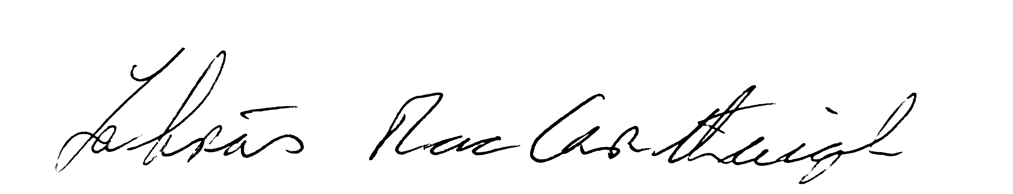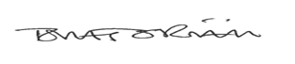

Labhrás Mac Carthaigh Tomás O Riain
Uachtarán Ard Stiúrthóir

